Illustration AD150

10-11-05

Book Suggestion: “The Illustrator in America” by Walt Reed

Two-Point Perspective
Also called “Oblique Perspective”

Picture Plane

This is because the faces of the object you are looking at on the picture plane are angled (oblique) in relation to the picture plane.

There are 3 types of movement within a picture: laterally (left-to-right, right-to-left), up and down, or in and out.

One-point perspective is about in and out movement.
Two-point perspective is about lateral movement.

Where one-point perspective features the face of an object, two-point features an edge of an object, or a corner of a room. Pg 34 in How to Draw Comics the Marvel Way shows an example of using one and two-point perspectives in interior scenes.
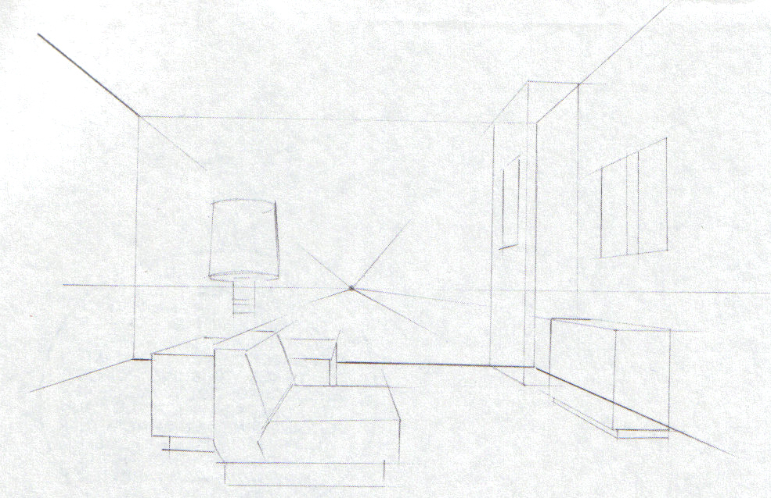
Figure 1 One-Point Interior
Figure 2 Two-Point Interior
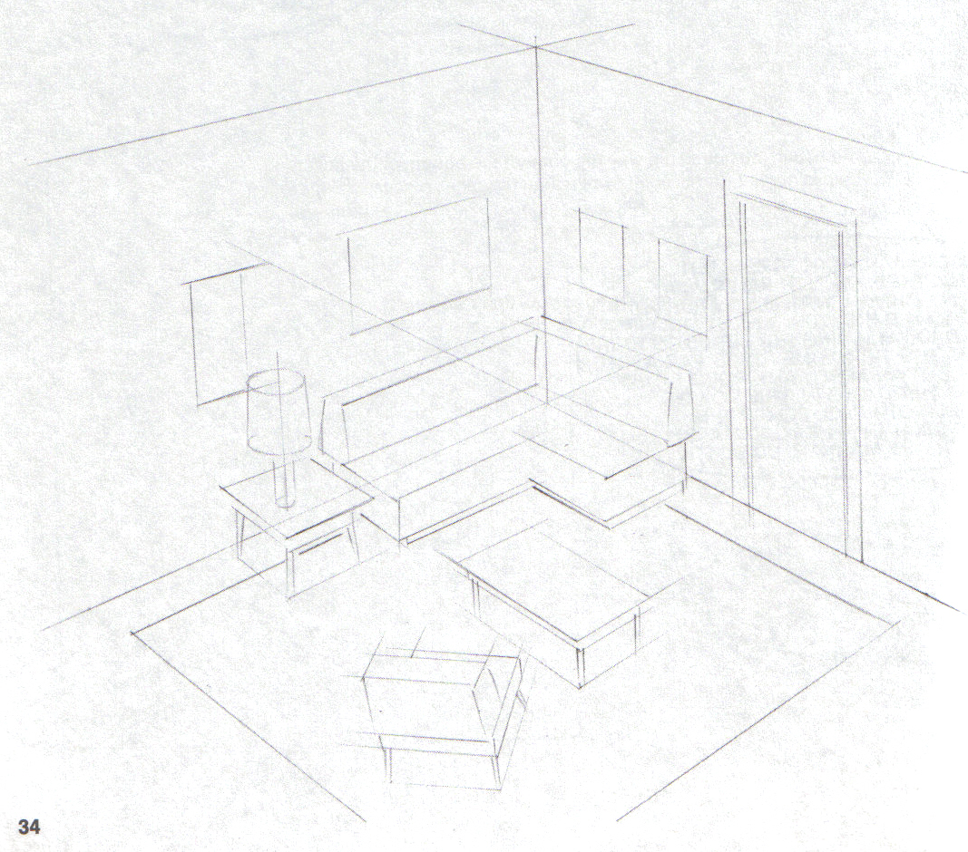

If you move the horizon line too high in 2-pt, it starts to distort your objects.
VPL Should NOT be placed closer than this point.
Farther away is better.
VPR
Placed First
Distance to VPR
Distance to VPL

To constrain your objects to the sizes you want, nail down the edge closest to you first, then take it to the VPs.

When adding your VPs, the first one can be arbitrary, but to keep things from distorting or looking “not quite right,” make sure the second VP is at least twice the distance from the corner as the first VP.

VPR refers to the VP at the Right of the image and VPL refers to the VP at the left on the image. This is to differentiate between the two.

The horizon line and VPs do not HAVE to be in the picture plane. If you need to place one or both VPs farther away than the page allows, do it. Always keep in mind though what you are trying to show in the image. If you get your VPs too far out, then the effect will bee too subtle and you may need to start thinking about using one-point perspective.

Kuntz Quote:
“If one-point gets too distorted, it starts calling for two-point. If two-point gets too distorted, It starts calling for three-point. If three-point gets too distorted, it starts calling for mommy.”

Illustration Masters to start studying

bpib.com

These names may or may not be on that site. If someone isn’t, search for them.
Find someone that speaks to you and really look at their style, technique, etc.
Howard Pyle
Haddon Sundblom
Dean Cornwell
Edwin Austin Abbey
Robert Fawcett
Bob Peak
Bernard (Bernie) Fuchs
John Pike
John Whorf
Joseph Clement Coll

Charles Dana Gibson
Elliot O’Hara
Ted Kautzky
Daniel Vierge
John Whitcomb
Albert Dorne
Harry Anderson
Andrew Loomis
LeRoy Neiman
Illustration Magazine

